NEIGHBORHOOD EVENT ORGANIZER
@CREATIVITY THINK (9483175986/7019689991)

ABSTRACT:
Neighborhood Event Organizer is a web application designed to streamline event management for societies, residential groups, and local communities. The platform enables users to create and view events, RSVP, sync events with calendars, participate in discussions, and track activities through a dashboard. Administrators can manage events, send notices, moderate discussions, and access analytics. Developed using Django and Django Rest Framework for backend processing, and React with recharts and socket.io for real-time communication, the system ensures efficient community coordination, enhanced engagement, and easy monitoring of all events and activities..

INTRODUCTION OF THE PROJECT:
Many residential communities struggle with managing local events, notices, and discussions effectively. Traditional communication methods such as group chats, notice boards, or emails are often fragmented and lack accountability. Neighborhood Event Organizer addresses these challenges by providing a centralized digital solution where users and administrators can coordinate events, share notices, and communicate efficiently. The platform fosters engagement, reduces confusion, and provides real-time visibility into event participation and community interactions..

PROJECT OBJECTIVES:

• Enable users to create, view, and RSVP for events
• Synchronize events with personal or community calendars
• Provide discussion forums and notice boards for community communication
• Allow administrators to add, edit, and manage events
• Moderate comments and chat discussions
• Offer dashboards with analytics for user engagement and event participation
• Ensure real-time updates using socket.io
• Maintain secure, scalable backend APIs for all operations

PROBLEM OF THE STATEMENT:
Traditional community event management often relies on fragmented communication channels, leading to miscommunication, missed events, and low participation. Tracking RSVPs, discussions, and notices manually is inefficient and error-prone. Neighborhood Event Organizer solves these issues by offering a centralized platform with event management, real-time discussion, RSVP tracking, calendar synchronization, and administrative analytics, improving community engagement and operational efficiency..

MOTIVATION OF THE PROJECT:
• To simplify and digitize neighborhood event management
• To provide accurate tracking of RSVPs and event participation
• To enhance community engagement through discussions and notices
• To streamline administrative control over events and communications
• To generate actionable insights via dashboard analytics
• To provide real-time updates and notifications
• To improve coordination and planning of local activities

BLOCK DAIGRAM OF PROJECT:

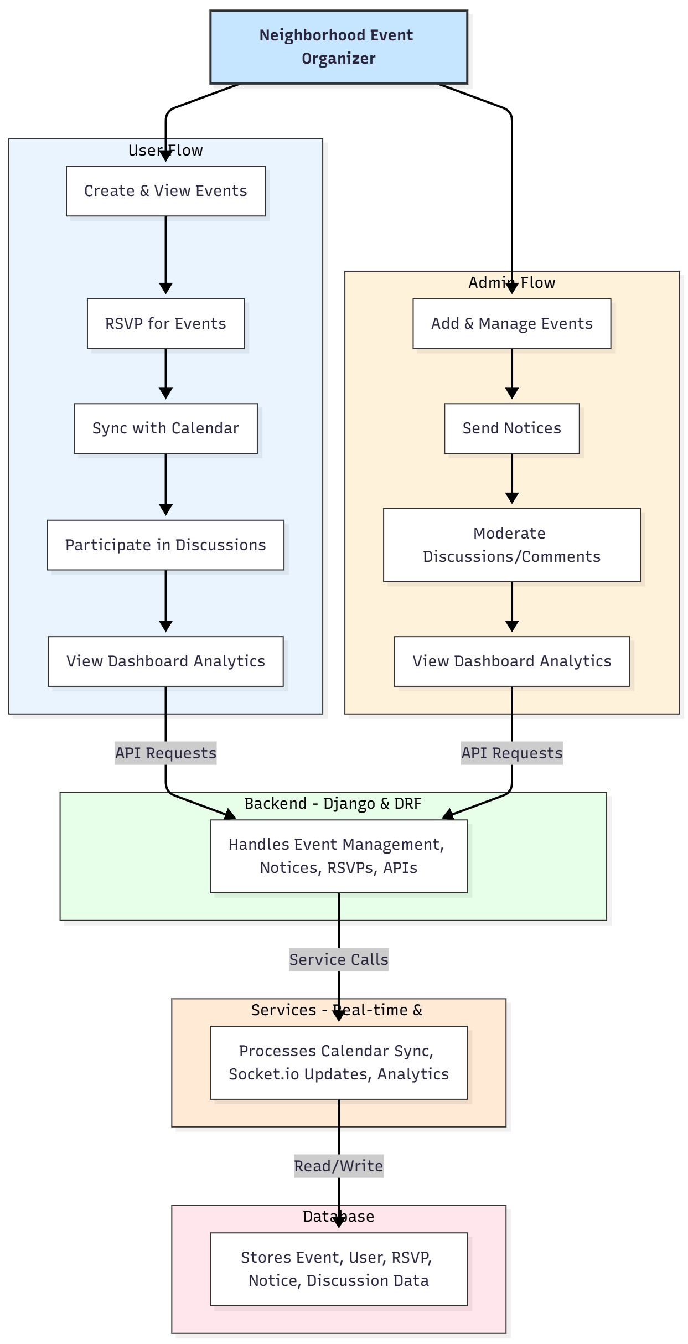

WORKING OF THE PROJECT:
Users start by creating or viewing events within the community. They can RSVP for events and sync event details with their personal calendars. Discussions and notice boards allow users to interact, share updates, and participate in real-time conversations. The backend validates and stores all event, RSVP, and discussion data. Administrators oversee event management, send notices, moderate discussions, and monitor engagement analytics through a dashboard. Real-time updates are enabled using socket.io, while the database stores all structured data securely. This workflow ensures organized community interaction and efficient event coordination..

SOFTWARE REQUIREMENT:
- Backend:
  - Python 3.x
  - Django
  - Django REST Framework
  - SQLite/PostgreSQL
- Frontend:
  - Node.js and npm
  - React.js
  - Axios
- Development Tools:
  - Visual Studio Code
  - Postman (for testing APIs)
  - Git/GitHub (for version control)
- Server/Deployment (Optional):
  - Gunicorn, Nginx, or Heroku/AWS for hosting

ADVANTAGES OF THE PROJECT:

• Centralized event and notice management
• Real-time discussion and notifications
• RSVP tracking and calendar synchronization
• Dashboard analytics for user engagement
• Secure and scalable backend operations
• Reduces miscommunication and missed events
• Efficient administrative control
• Enhances community participation and planning

APPLICATIONS OF THE PROJECT:
• Residential societies and apartments
• Local community or resident groups
• Schools and neighborhood organizations
• Clubs or hobby groups organizing events
• Community service and awareness programs

REFERENCES:

- Django REST Framework Documentation — Django Software Foundation. Django Documentation. Available: https://docs.djangoproject.com/
- Django REST Framework. DRF Documentation. Available: https://www.django-rest-framework.org/
- React. React Official Documentation. Available: https://reactjs.org/docs/getting-started.html
- Redux. Redux Documentation. Available: https://redux.js.org/introduction/getting-started
- PostgreSQL Global Development Group. PostgreSQL Documentation. Available: https://www.postgresql.org/docs/
- MySQL. MySQL Reference Manual. Available: https://dev.mysql.com/doc/
- Git. Git Documentation. Available: https://git-scm.com/doc
- Node.js. Node.js Documentation. Available: https://nodejs.org/en/docs/
- Axios. Axios Documentation. Available: https://axios-http.com/docs/intro
- Socket.io Documentation – https://socket.io/docs/

